VEHICLE TECHNICIAN ACCREDITATION ASSESSMENT

PRACTICAL TASKS RESOURCES

Updated: 31 March 2025

Indicative review date: 31 March 2028

# Suspension, Steering, Wheels & Tyres

|  |  |
| --- | --- |
| **Module** | Suspension, Steering, Wheels & Tyres |
| **Task** | Sus – 01 |
| **Task Title** | Tyre Wear |
| **Resource** | 5 images of tyre wear  3 of the images must be selected and presented to the technician |

# http://www.sam4x4.com/images/auto-articles-images/tire-wear_patterns.jpgTyre Wear – Image A

# Tyre Wear – Image B

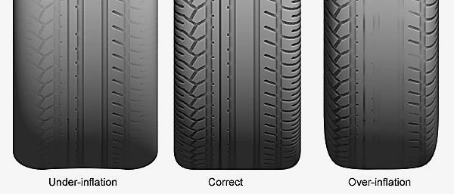

# Tyre Wear – Image C

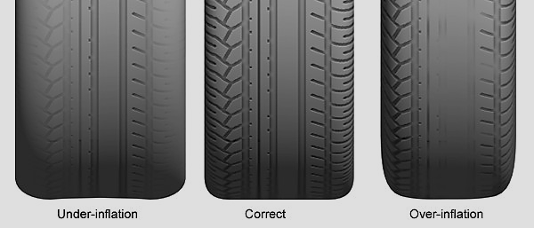

# Tyre Wear – Image D

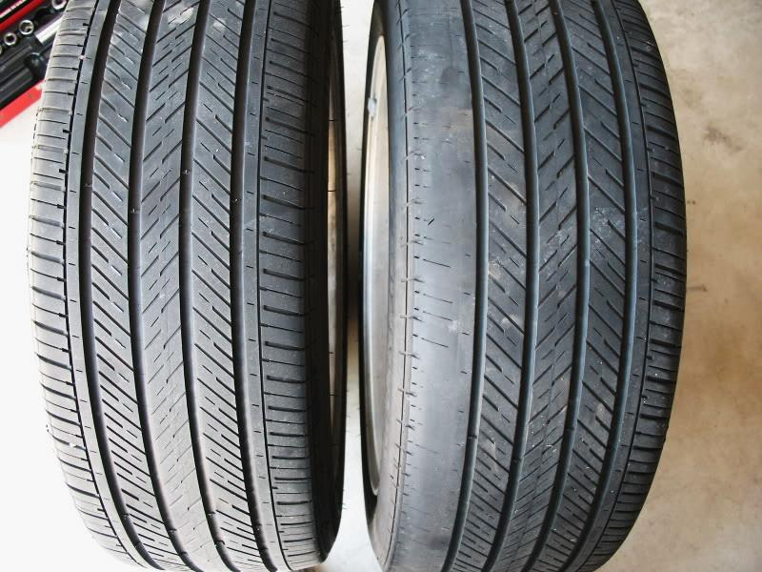

**Inner Edge Outer Edge**

**1mm 3mm 5mm**

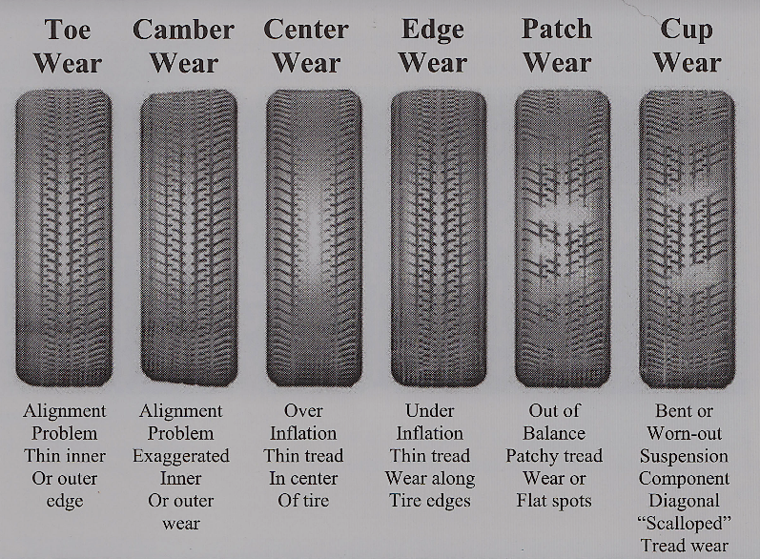

# Tyre Wear – Image E

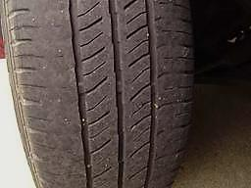

**Outer Edge Inner Edge**

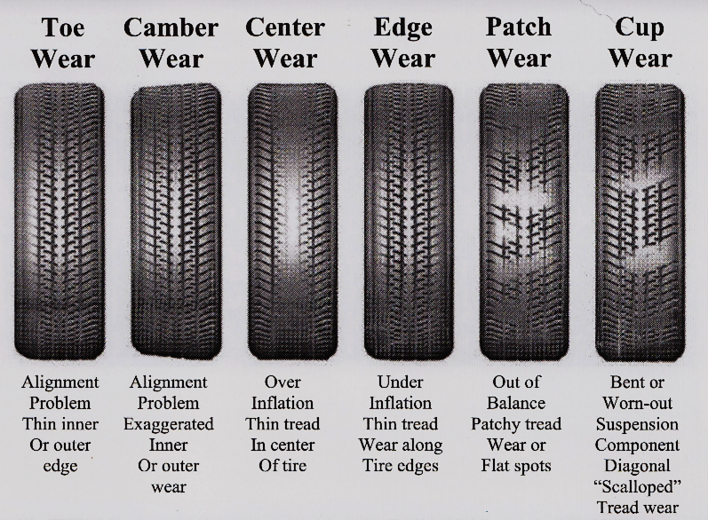

**5mm 3mm 1mm**

# Electrical

|  |  |
| --- | --- |
| **Module** | Electrical |
| **Task** | Ele – 09 |
| **Task Title** | Oscilloscope Waveform ID |
| **Resource** | Illustration of different oscilloscope waveform types  5 of the images must be selected and presented to the technician |

# Oscilloscope Waveform – Image A

# Oscilloscope Waveform – Image B

# Oscilloscope Waveform – Image C

# Oscilloscope Waveform – Image D

# Oscilloscope Waveform – Image E

# Oscilloscope Waveform – Image F

# Oscilloscope Waveform – Image G

# Oscilloscope Waveform – Image H

# Oscilloscope Waveform – Image I

# Oscilloscope Waveform – Image J

# Oscilloscope Waveform – Image K

# Oscilloscope Waveform – Image L

# Trainer Guidance: Emission 03

|  |  |
| --- | --- |
| **Module** | Emission |
| **Task** | Emi – 03 |
| **Task Title** | Emission Test Sample |
| **Resource** | Illustration of five different sets of emission data which relate to different engine faults.  Each set of data should be labelled with a letter A-E prior to presenting them to the technician.  The data sets represent the following faults:  Fuel misfire  Ignition misfire  Exhaust leak  Inlet manifold leak  No emission fault(s) |

# Emission test results

|  |  |  |  |
| --- | --- | --- | --- |
| Analyser result(s) | | | |
| CO | 0.1 | % |
| HC | 75 | ppm |
| CO2 | 14.5 | % |
| O2 | 0.5 | % |
| Lambda | 1.003 | | |

# Emission test results

|  |  |  |  |
| --- | --- | --- | --- |
| Analyser result(s) | | | |
| CO | 0.5 | % |
| HC | 70 | ppm |
| CO2 | 10.2 | % |
| O2 | 5.6 | % |
| Lambda | 1.3 |  |

# Emission test results

|  |  |  |  |
| --- | --- | --- | --- |
| Analyser result(s) | | | |
| CO | 0.76 | % |
| HC | 1258 | ppm |
| CO2 | 9.32 | % |
| O2 | 2.6 | % |
| Lambda | 0.89 |  |

# Emission test results

|  |  |  |  |
| --- | --- | --- | --- |
| Analyser result(s) | | | |
| CO | 0.89 | % |
| HC | 11 | ppm |
| CO2 | 15.17 | % |
| O2 | 4.45 | % |
| Lambda | 1.24 |  |

# Emission test results

|  |  |  |  |  |  |
| --- | --- | --- | --- | --- | --- |
| Analyser result(s) | | | | | |
| CO | 0.34 | | % |
| HC | 16 | | ppm |
| CO2 | 12.1 | | % |
| O2 | 11.56 | | % |
| Lambda | 1.13 | |  |
|  | |  | | |